Lab 5 - Developing Web Application using Django-Part I

Q1 - Create a web form which allows the teacher to enter the student details like name,
date of birth, address, contact number, email id and marks of English, Physics and
Chemistry. After filling all the information and on clicking submit button, details
should be added to a textarea displayed on the same page. Display the total
percentage of marks obtained in a label.

Code -

views.py-
from django.shortcuts import render
from .forms import StudentForm

def student_view(request):
form = StudentForm()
student_data = None
if request.method == 'POST':
form = StudentForm(request.POST)
if form.is_valid():
student_data = form.cleaned_data
percentage = (student_data['english_marks'] + student_data['physics_marks'] + student_data['chemistry_marks']) / 3
student_data['percentage'] = percentage
return render(request, 'student_form.html', {'form': form, 'student_data': student_data})

student.html-
<!DOCTYPE html>
<html lang="en">
<head>
<meta charset="UTF-8">
<meta name="viewport" content="width=device-width, initial-scale=1">
<title>Student Form</title>

<!-- Bootstrap CSS -->
<link href="https://cdn.jsdelivr.net/npm/bootstrap@5.3.0/dist/css/bootstrap.min.css" rel="stylesheet">

<style>
body {
background-color: #f8f9fa;
}
.container {
max-width: 600px;
margin-top: 50px;
background: white;
padding: 20px;
border-radius: 8px;
box-shadow: 0px 0px 10px rgba(0, 0, 0, 0.1);
}
.form-label {
font-weight: bold;
}
textarea {
width: 100%;
height: 220px;
resize: none;
font-size: 14px;
}
</style>
</head>
<body>

<div class="container">
<h2 class="text-center text-primary">Enter Student Details</h2>

<form method="post" class="mt-3">
{% csrf_token %}
<div class="mb-3">
{{ form.as_p }}
</div>
<button type="submit" class="btn btn-success w-100">Submit</button>
</form>

{% if student_data %}
<div class="mt-4">
<h3 class="text-center text-info">Student Details</h3>
<textarea class="form-control" readonly>
Name: {{ student_data.name }}
DOB: {{ student_data.dob }}
Address: {{ student_data.address }}
Contact: {{ student_data.contact_number }}
Email: {{ student_data.email }}
English: {{ student_data.english_marks }}
Physics: {{ student_data.physics_marks }}
Chemistry: {{ student_data.chemistry_marks }}
Percentage: {{ student_data.percentage }}%
</textarea>
</div>
{% endif %}
</div>

<!-- Bootstrap JS -->
<script src="https://cdn.jsdelivr.net/npm/bootstrap@5.3.0/dist/js/bootstrap.bundle.min.js"></script>

</body>
</html>
Output -
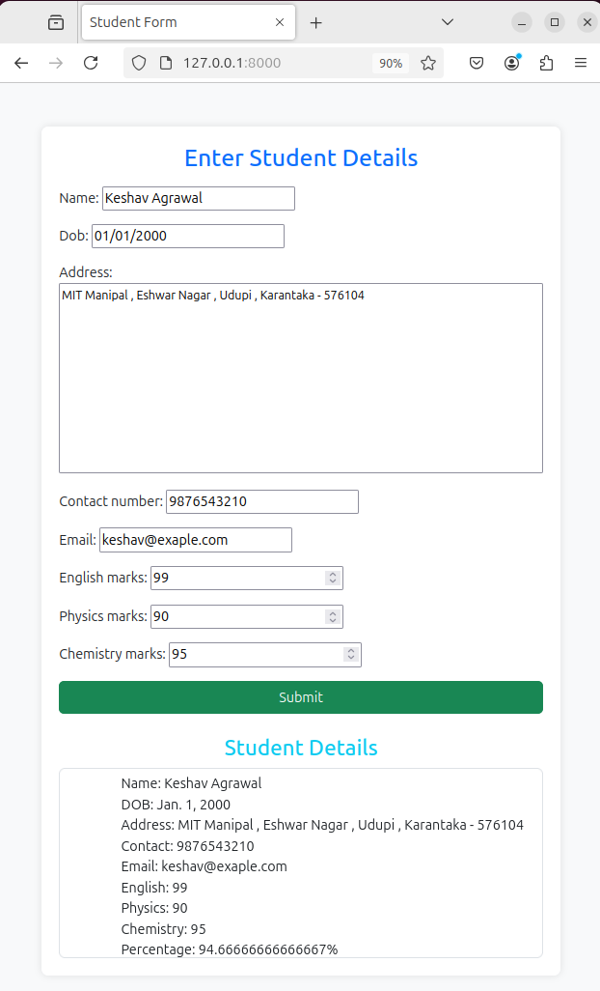

Q2 - Create a web form with employee ids in dropdown list. Use a textbox for accepting
date of joining. Add a button named “Am I Eligible for Promotion”. On clicking
the button, if he has more than 5 years of experience, then display “YES” else
“NO” in the label control.

Code -

views.py -
from django.shortcuts import render
from django.http import JsonResponse
from .models import Employee
from datetime import date

def employee_form(request):
employees = Employee.objects.all()
return render(request, 'employee_forms.html', {'employees': employees})

def check_promotion(request):
if request.method == 'POST':
emp_id = request.POST.get('emp_id')
employee = Employee.objects.get(emp_id=emp_id)
doj = employee.date_of_joining
experience = (date.today() - doj).days // 365

eligible = "YES" if experience >= 5 else "NO"
return JsonResponse({'eligible': eligible})

employee.html-
<!DOCTYPE html>
<html lang="en">
<head>
<meta charset="UTF-8">
<meta name="viewport" content="width=device-width, initial-scale=1.0">
<title>Employee Promotion Check</title>
<style>
body {
font-family: Arial, sans-serif;
margin: 50px;
text-align: center;
}
select, input, button {
margin: 10px;
padding: 10px;
}
#result {
font-size: 20px;
font-weight: bold;
color: blue;
margin-top: 20px;
}
</style>
</head>
<body>

<h2>Check Promotion Eligibility</h2>

<label for="emp_id">Select Employee ID:</label>
<select id="emp_id">
{% for employee in employees %}
<option value="{{ employee.emp_id }}">{{ employee.emp_id }}</option>
{% endfor %}
</select>

<button onclick="checkPromotion()">Am I Eligible for Promotion?</button>

<div id="result"></div>

<script>
function checkPromotion() {
var emp_id = document.getElementById("emp_id").value;

fetch('/check_promotion/', {
method: 'POST',
headers: {
'Content-Type': 'application/x-www-form-urlencoded',
'X-CSRFToken': '{{ csrf_token }}'
},
body: 'emp_id=' + emp_id
})
.then(response => response.json())
.then(data => {
document.getElementById("result").innerText = "Eligible: " + data.eligible;
})
.catch(error => console.error('Error:', error));
}
</script>

</body>
</html>

Output -

